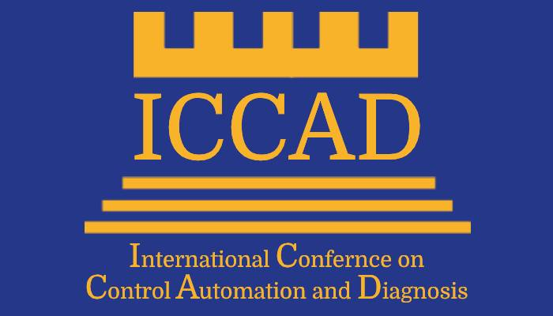

CALL FOR PAPERS
SPECIAL SESSION ON
(Special Session Title...................)
for ICCAD’22
July13-15, 2022,Lisbon-Portugal

Session Co-Chairs:
- (Full Name, Affiliation, e_mail address)………………………………………………………………………………………………
- (Full Name, Affiliation, e_mail address)………………………………………………………………………………………………
- (Full Name, Affiliation, e_mail address)………………………………………………………………………………………………

Session description:
This special session deals with the problem of..........................................................................................
.........…………………………………………………………………………….………………………………………………………………………
.........…………………………………………………………………………….………………………………………………………………………

The goal is to…………………………………………................……………………………………………………………………………….........…………………………………………………………………………….………………………………………………………………………
.........…………………………………………………………………………….………………………………………………………………………

The topics of interest include, but are not limited to:
-……………………………………………………………………………………………………………………………………………………………
-……………………………………………………………………………………………………………………………………………………………
-……………………………………………………………………………………………………………………………………………………………

SUBMISSION
Papers must be submitted electronically for peer review by: March 31, 2022
http://www.iccad-conf.com/submission.html

All papers must be written in English and should describe original work. The length of the paper is limited to a maximum of 6 pages (in the standard IEEE conference double column format).

